1.First page -Should be dynamic.
Use white bright theme. Please prefer website https://www.trimurti-enterprises.com/index.php.

Template -Pls use latest one .
2. @ Pls remove it
3.First page -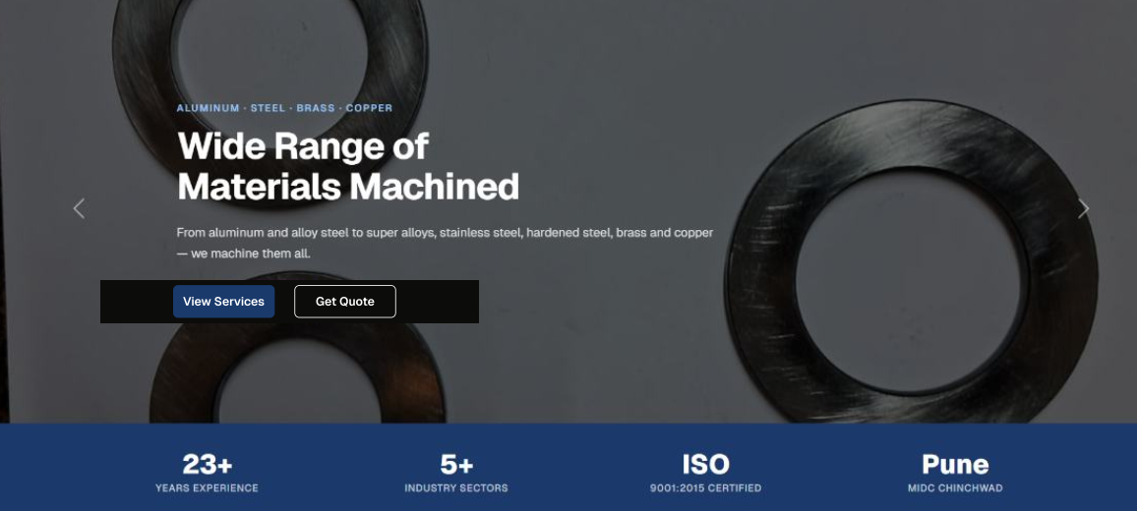
Not like this
Tagline should be – Manufacturer and supplier of CNC-VMC precise machined components.
Background-CNC -VMC machine at one side and other side components like Trimurti

4.Our machines- Use machine photos like Trimurti
5.Don’t use components photos in every page
6.Take photo from google and also use our company profile.
7.Quality inspection- Use actual photos of machines and remove component photo
- Insert ISO certificate
8.Our best achievement – Insert RSB transmission trophy and certificate photo also., Hydroulic fixtures photo also
9.contact us – business hours 24 hours

